**Lab Practical #04:**

Installation of Network Simulator (Packet Tracer) and Implement different LAN topologies.

**Practical Assignment #04:**

1. **Create a simple network with switch and two or more pc. Also check connectivity between them using ping command or PDU utility.**

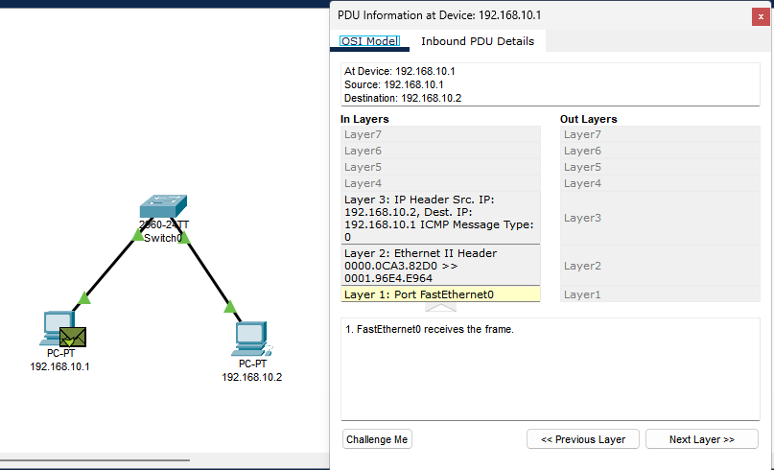

1. **Implement different topologies in packet tracer.**
   1. **Bus**
   2. **Ring**
   3. **Star**
   4. **Mesh**
   5. **Tree**

**a.BUS**

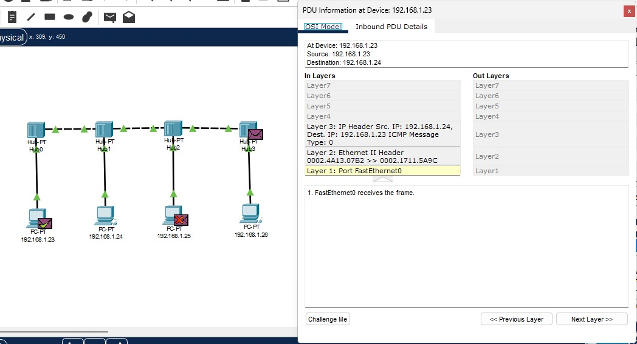

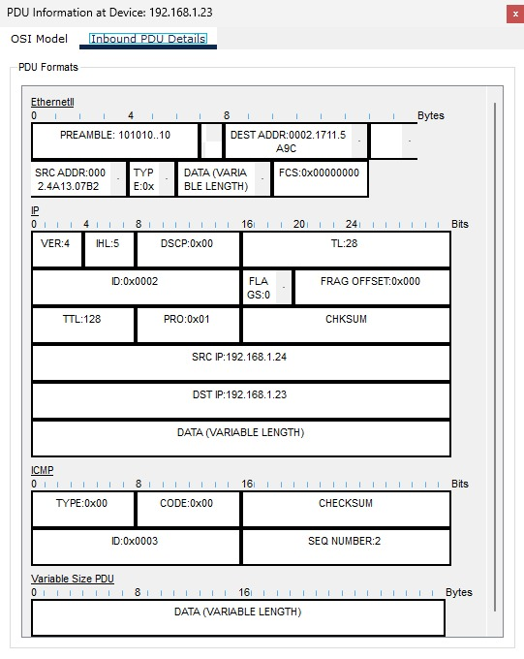

**b.RING**

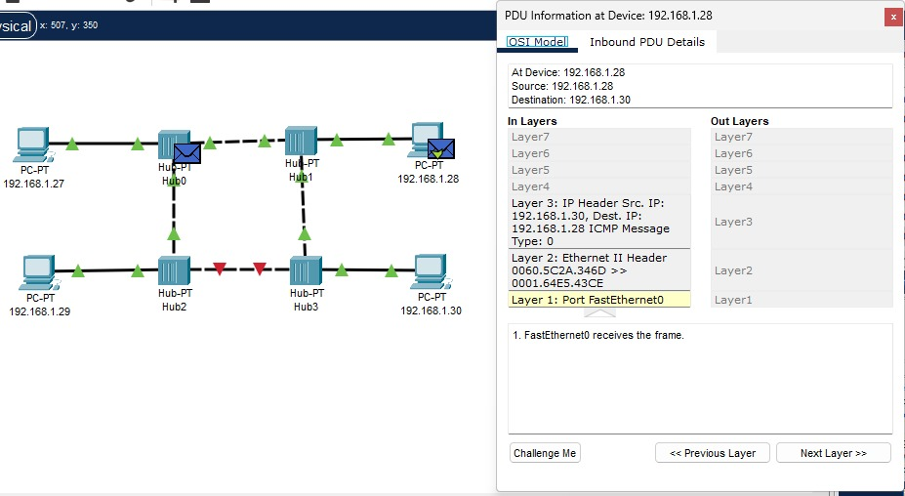

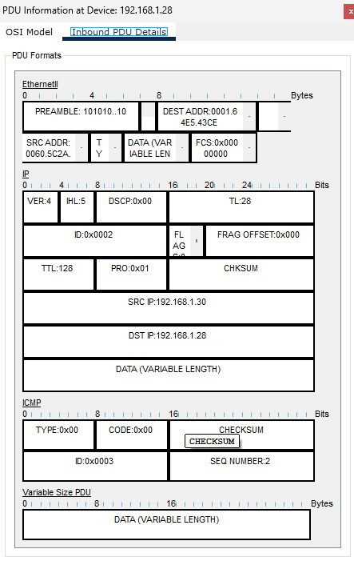

**c. STAR**

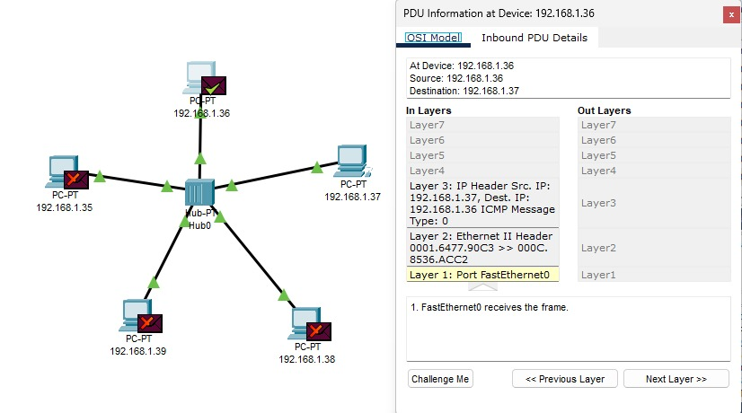

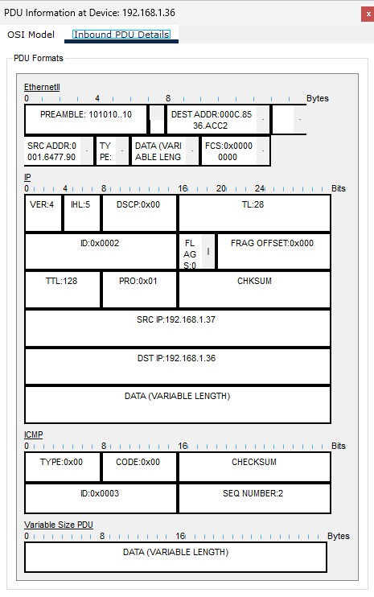

**d.mesh**

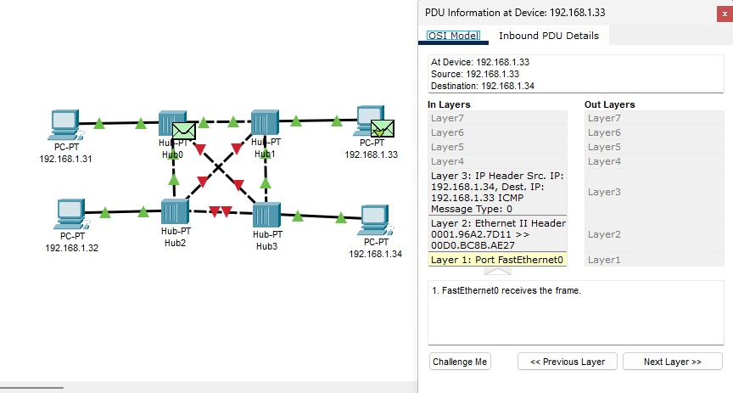

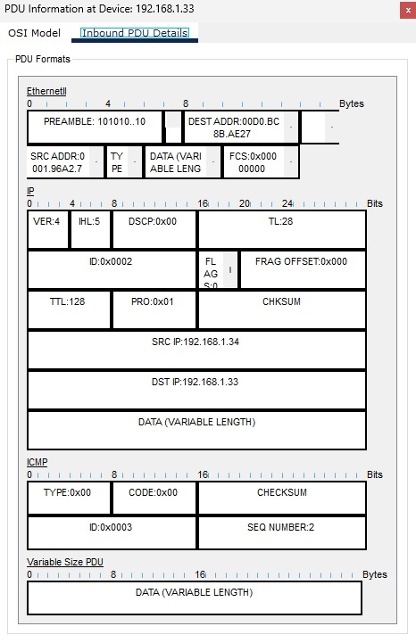

**e.tree**

